

Gas Extinguishing System Solution in Semerkand Factory

EPC by Grextech Fire and Building Solution

LV Room

Since there are electronic equipment in this room, it is not suitable to use a water extinguishing system.
This room is protected with Fm200 automatic gas extinguishing system called clean gases.
This room; NFPA2001 Class C (electrical fires) was taken into consideration and the amount of gas was determined with a concentration rate of 7%.
Space protection has been made to ensure the discharge of gas into the room and raised floor at the same time.

Cylinders;

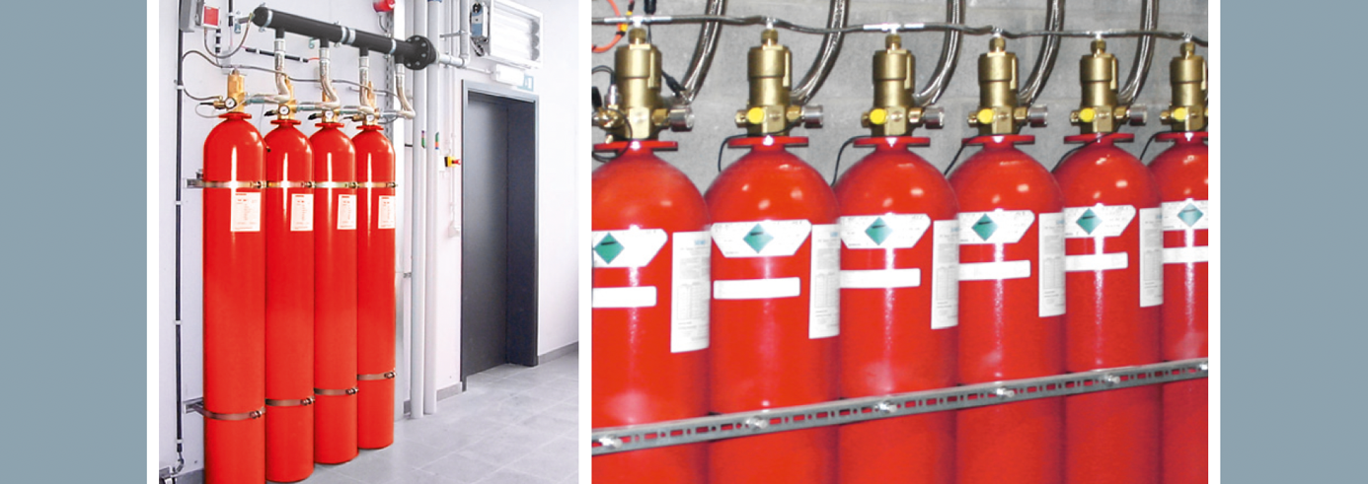

Nozzles;

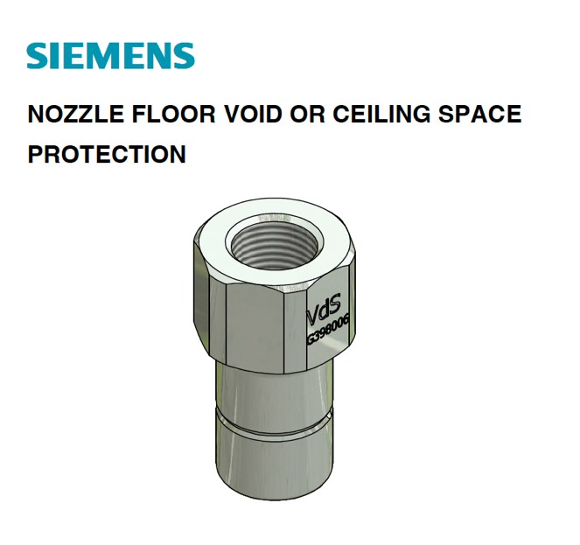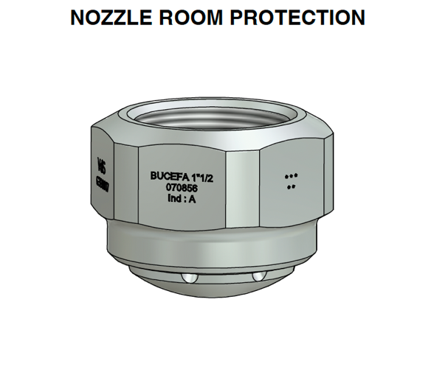

Example image;

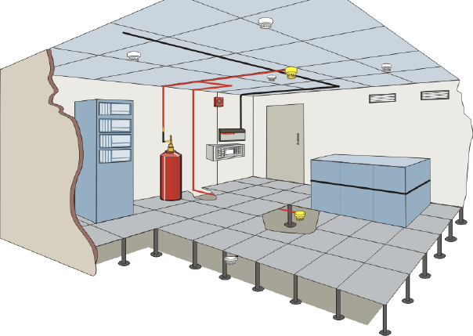

Isometry Projects;

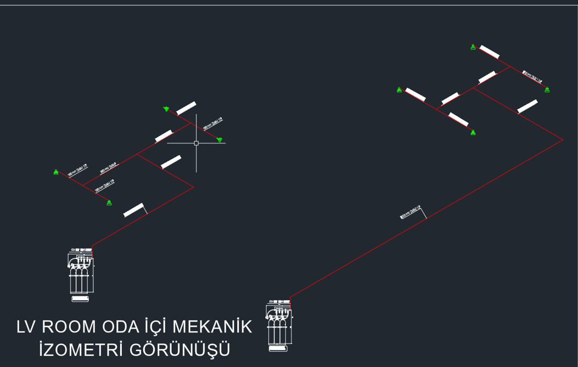

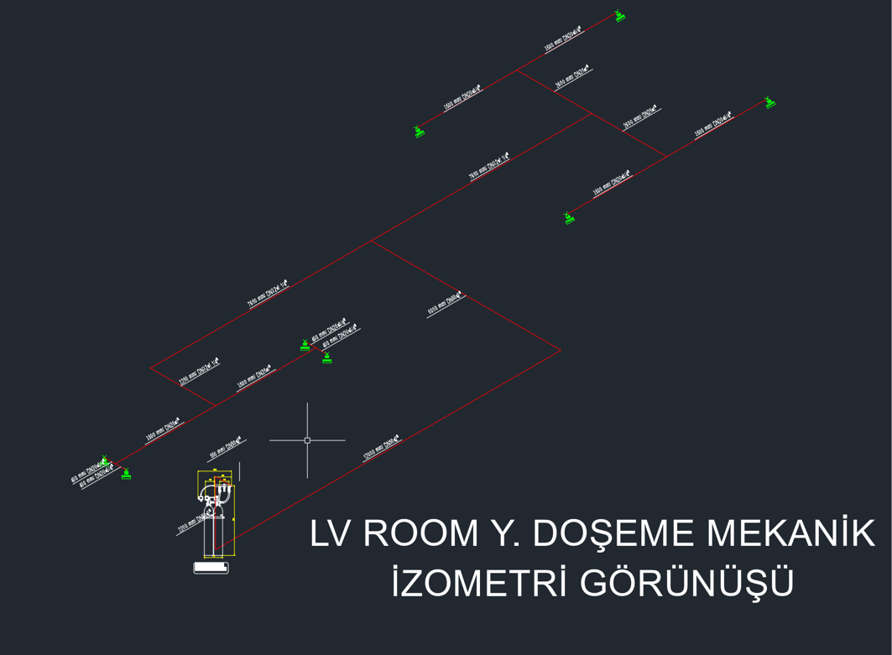

UPS Room

Since there are electronic equipment in this room, it is not suitable to use a water extinguishing system.
This room is protected with Fm200 automatic gas extinguishing system called clean gases.
This room; NFPA2001 Class C (electrical fires) was taken into consideration and the amount of gas was determined with a concentration rate of 7%.
Space protection has been made to ensure the discharge of gas into the room and raised floor at the same time.

Cylinders;

Nozzles;

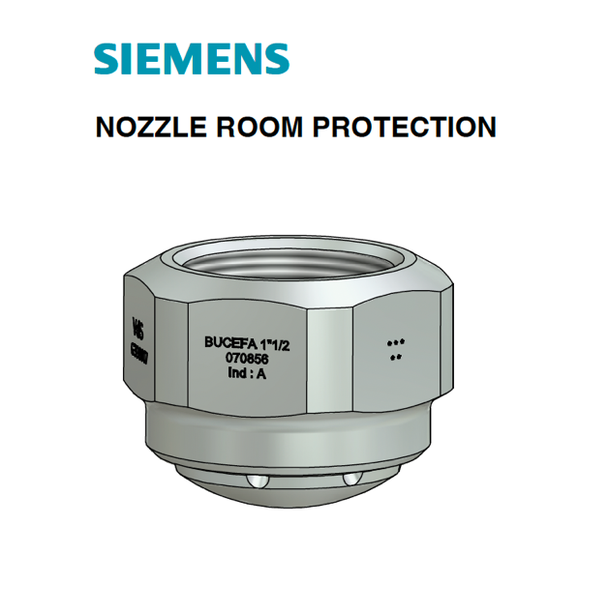

Example image;

Isometry Projects;

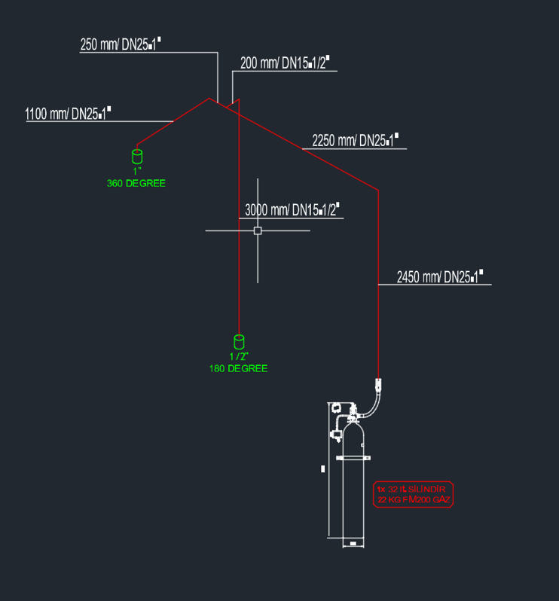
IT & System Room

Since there are electronic equipment in this room, it is not suitable to use a water extinguishing system.
This room is protected with Fm200 automatic gas extinguishing system called clean gases.
This room; NFPA2001 Class C (electrical fires) was taken into consideration and the amount of gas was determined with a concentration rate of 7%.
Space protection has been made to ensure the discharge of gas into the room and raised floor at the same time.

Cylinders;

Nozzles;

Example Image;

Isometry Projects;

